

**KINGSWAY CHRISTIAN COLLEGE**

**Year 12 ATAR Physics 2017**

**Task 8**

**Wave Particle Duality & Quantum Theory Test**

Name _______________________________________________

Date due: ***Friday, 04 August 2017***

**Time allowed 80 minutes**

|  |  |  |
| --- | --- | --- |
|  | **Available mark** | **Student mark** |
| 1 | 12 |  |
| 2 | 8 |  |
| 3 | 11 |  |
| 4 | 12 |  |
| 5 | 10 |  |
| 6 | 22 |  |
| 7 | 6 |  |
| ***Total marks*** | ***80*** |  |
| ***%*** | ***100*** |  |

1. Scientists use models which could be rejected and then later accepted as evidence supporting the model becomes overwhelming.

(a) What is a scientific model? [2]

(b) List three phenomena that support the particle nature of light. [3]

(c) List three phenomena that support the wave nature of light. [3]

(d) List two phenomena that support both the wave and particle nature of light. [2]

(e) Name two devices developed from the application of quantum Physics that have significantly changed many aspects of society. [2]

2. (a) What is the photoelectric effect? [2]

(b) A photon of blue light has a wavelength of 450 nm. Calculate the:

(i) Photon’s energy in eV. [2]

(ii) Photon’s momentum [2]

(c) Give two uses of the photoelectric effect. [2]

3. (a) Explain why the photoelectric effect supports the particle model of light rather than the wave theory? [3]

(b) It is found that when light above a certain frequency illuminates the surface of a metal, electrons are liberated from the metal. In an experiment to determine how the maximum kinetic energy of the emitted electrons varies with frequency, the following graph was obtained.

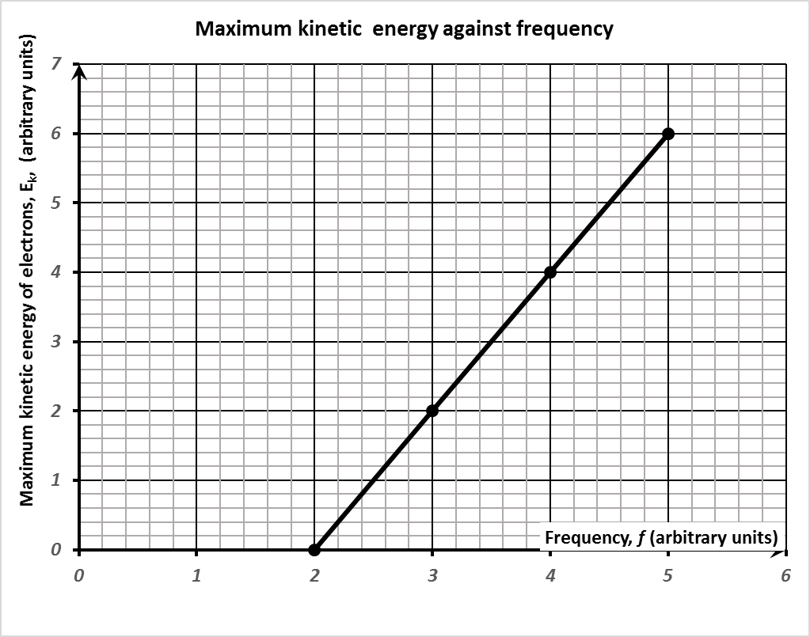

***f0***

(i) Write an equation for this line. [1]

(ii) Explain the significance of the frequency ***f0***. [2]

(iii) What will be the maximum kinetic energy of the electrons emitted at frequency 3***f0***? [2]

(iv) What is the work function of the metal and where would it plot on the graph? [2]

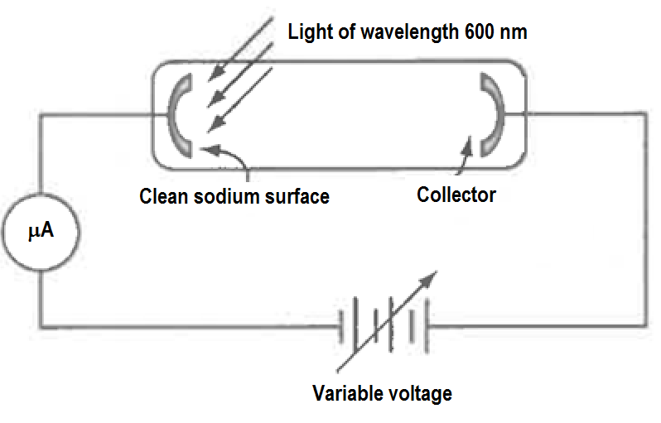4. Light of wavelength 600 nm is shone unto a clean sodium surface. Sodium has a work function of 3.7 × 10−19 J. The diagram of the setup is shown below.

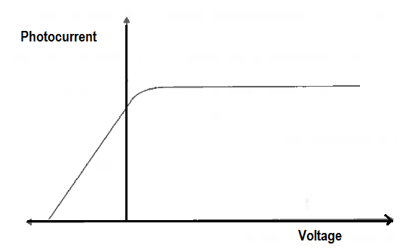The output of the micro ammeter reading as the voltage is increased from very negative values towards positive values is plotted below.

(a) What is meant by work function? [1]

(b) Calculate the energy of the light photon in eV. [2]

(c) What is the stopping voltage for the photoelectrons produced. [1]  
(c) On the photocurrent/voltage sketch, draw the graph if the intensity of the 600 nm light was reduced to ½ it’s initial intensity. [2]

(d) On the photocurrent/voltage sketch, draw the graph if instead of the 600 nm light, a 300 nm UV photon of ¼ it’s initial intensity was used. [2]

(e) The 300 nm UV photons are from a 5 mW source with an efficiency of 80%. How many photons would this source emit in 3 minutes? [4]

5. Define the following terms:

(a) Spectrum [1]

(b) Continuous spectrum and substances that produce it. [2]

(c) Emission spectrum and substances that produce it. [3]

(d) Absorption spectrum and substances that produce it. [3]

(e) Spectroscope [1]

6. The energy level diagram for a hydrogen atom is shown below.

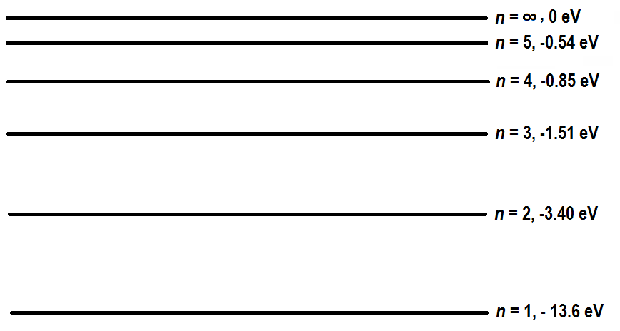

(a) 14.9 eV photons interact with hydrogen atoms in the ground state. Fully describe the result of this interaction. [4]

(b) 14.9 eV electrons interact with hydrogen atoms in the ground state. Fully describe the result of this interaction. [6]

(c) Electrons of a certain energy interacted with hydrogen atoms in the ground state. The scattered electron energies after interaction with the hydrogen atoms were   
0.14 eV, 0.45 eV, 1.11 eV, 3.00 eV, and 13.2 eV.

(i) What was the energy of the interacting electrons in Joules. [2]

(ii) List all possible photon energies in eV, emitted by the excited hydrogen atoms. Show the transitions responsible for the photon emissions on a clear energy diagram. [10]

7. A 38.4 nm photon is required to ionise an atom in the ground state and give the ejected electron a kinetic energy of 10.0 eV.

(a) What is the ionisation energy of the atom? [2]

(b) What is the approximate slit width that will diffract an electron with the same energy as the 38.4 nm photon? (Neglect relativistic effects) [2]

(c) A Ferrari car with a mass of 1400 kg approaches a freeway underpass that is 10 m across. At what speed must the car be moving, in order for it to have a wavelength such that it might somehow “diffract” after passing through this “single slit”? [2]

**END OF TASK 8**